**Rev No: 03 Unit: PID II**

**Date: 15.11.2020 Dept.: Mechanical**

FORMAT FOR HAZARD IDENTIFICATION

A. Work activity information – Dedusting maintenance

|  |  |  |
| --- | --- | --- |
| **Sr.No.** | **Details** | **Remark** |
| 1) | Task being carried out, their duration and Frequency: | Maintenance of PCM and Caste house DD  1 to 8 hours  Weekly/Monthly |
| 2) | Location (s) where the work is carried out. | PCM and Caste house DD |
| 3) | Who normally/occasionally carried out the task | Engineer in charge  Maintenance fitter/welder on the job  Contractor workmen on job |
| 4) | Who else may be affected by the work (For example visitors, subcontractors, the public) | Contractor workmen, Production/Electrical Engineers , Visitors |
| 5) | a)Has the personnel trained for performing the task  b) Any special training required | Yes (Past experience)  Yes |
| 6) | Is the written system of work mandatory? If yes state the procedure no. | **VL/IMS/PID2/BF3/WI/24** |
| 7) | Is the work permit required for the task | Yes |
| 8) | Plant and machinery that may be used:  Eg : crusher, conveyor, crane, heavy earthing equipment, Truck etc, | Hoist, Hydra, Chain pulley block. |
| 9) | Any electrically operated hand tools are used | Yes (Grinders for grinding operation, Welding machine for welding operation) |
| 10) | Manufacturer’s or supplier’s instructions for operation and maintenance plant machinery and powered hand tools are available or not: | NO |
| 11) | Chain block, tools and shackles such as wire rope, hydraulic jack etc are used. | Chain pulley block of rated capacity, slings, D-shackles, wire ropes |
| 12) | What materials are handled? Size, shape, surface character and weight of materials that may be handled: | Irregular shape  Approximately max 5T |
| 13) | Is the material is required to be moved by hand. If yes Distance and heights of the place where materials have to move by hand. | 25 kgs by hand  2 mt height and 2 mt distance. |
| 14) | Services used Eg: compressed air, oxygen, acetylene,  LPG gas, hydraulic oil, welding electrode for welding | Yes. Welding electrode for welding  Oxygen, Acetylene, Compressed air, hydraulic oil |
| 15) | Physical form of substances encountered during the work (For example fume, gas, vapour, liquid, dust/powder, solid): | Solid, fumes, dust , graphite and nitrogen, liquid(oil) |
| 16) | Content and recommendations of safety data sheets relating to substances used or encountered:  ( this is applicable in case of chemical material) | NA |
| 17) | a) Relevant acts, regulations and standards relating to the work being done, the plant and machinery used and the materials used or encountered:  b) Is the activity is reviewed for compliance to statutory requirement | Factory Act  Yes |
| 18) | What is the data (s) required to be monitored during the activity and the frequency of monitoring. | Monitoring of noise level after every 3 months |
| 19) | Any information available from within and outside the organization on incident, accident and ill health experience associated with the work being done, equipment and substances used: | 1. On 30.09.2015 in a shift PCM de-dusting fan silencer net small piece pass through chimney and fell down on ground. There were no injury to anybody |

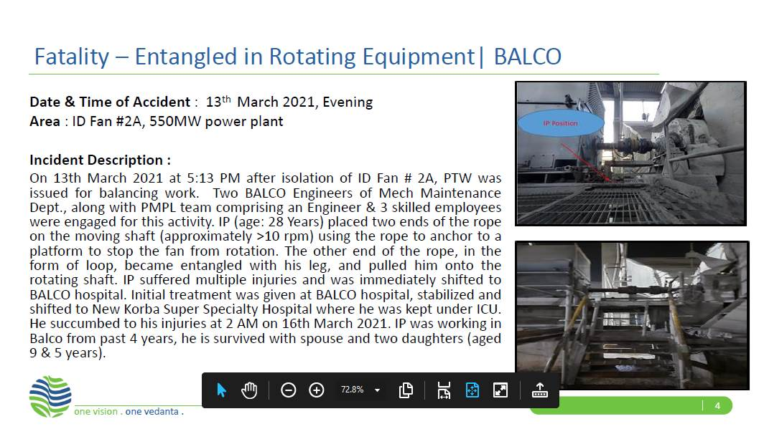

2. From the above activity information hazards are to be identified and recorded below using Appendix 'A' of SP/41

**HAZARDS IDENTIFIED**

**Physical Hazard**

1. Noise, vibration, pressure, temperature.
2. Impact of pressurized air/nitrogen on the body.
3. Fire and Explosion.
4. Slip and fall due to oil spillage.
5. Slipping due to accumulation of graphite/poor housekeeping.

**Mechanical Hazard**

1. Fall of material, Casing, Assembly due to irregular size
2. Crushing of person while lifting the material & fall
3. Fall while installation of Equipment.
4. Trapping of person during the fall of material from height
5. Fall of material due to mass & stability
6. Failure of lifting machines, handling machines such as chain pulley block, sling, D shackle etc.
7. Back Pain due to sudden or heavy load like vane feeder, motor, scrapper conveyor gear box.
8. Cut from sharp edges of item.
9. Non use of PPE’s while carrying out the activity.
10. Hitting of slinged items on existing structures / running machinery.
11. Fall of person inside hopper while cylinder/cylinder cover replacement.

**Electrical hazard**

1. Electric shock due to contact with open end cables & superficially laid underground electric cables.
2. Electric shock from overhead lines due to contact with overhead lines**.**

**Behavioral Hazards**

1. Alcoholism.
2. Non usage of PPE’s
3. Casual approach while working.
4. Non usage of correct tools.

**Chemical hazard** –

* 1. Fire in baghouse filters

|  |  |  |  |  |  |  |
| --- | --- | --- | --- | --- | --- | --- |
| |  |  | | --- | --- | | **Prepared By:**  **Mechanical In charge BF3 Plant** | **Reviewed By:**  **HOD Mechanical Maintenance PID-2** | | **Signature:** | **Signature:** | | **Date: 15.11.2020** | **Date: 15.11.2020** | |